26.10: a) The three resistors 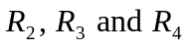are in parallel, so: 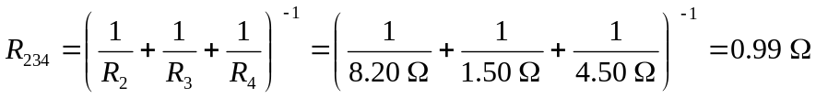
.
b) 